ECSE-200 Electric Circuits 1 - Quiz #8 (Mar. 15, 2019)

**LAST NAME** ______________________________________________ **MCGILL ID#** __________________

**FIRST NAME­­­­­­­­­**________________________________**SIGNATURE**_________________________________

* ***Only Faculty standard calculator accepted***
* ***No cellphone allowed***
* ***Show all your work***
* ***Clearly indicate your final answer with the SI unit and multiplier***
* ***You have 45 minutes to complete this quiz***

**__________________________________________________________________________________________**

**Question 1:** Consider the 100 μF capacitor (C = 100 μF) shown below along with the diagram illustrating the current *i(t)* flowing through the capacitor. A constant current of 20 mA flows through the capacitor up to time *t* = 2 ms. At that time *t* = 2 ms, the current drops to 10 mA until time *t* = 4 ms. For *t* > 4 ms, the current is 0 A. The capacitor is initially charged at *t* = 0 ms and has a voltage of 3 V across it. Answer the following questions.

1. At what time *t* will the capacitor have a charge separation of 350 μC (*q* = 350 μC)? [2 pt]
2. What is the instantaneous power at *t* = 1 ms? [2 pt]
3. What is the energy stored as electric potential energy *U(t)* in the capacitor at time *t* = 5 ms? [2 pt]

Extra Working Space

**Question 2:** The circuit shown below is a common operational amplifier (op-amp) circuit. Answer the following questions.

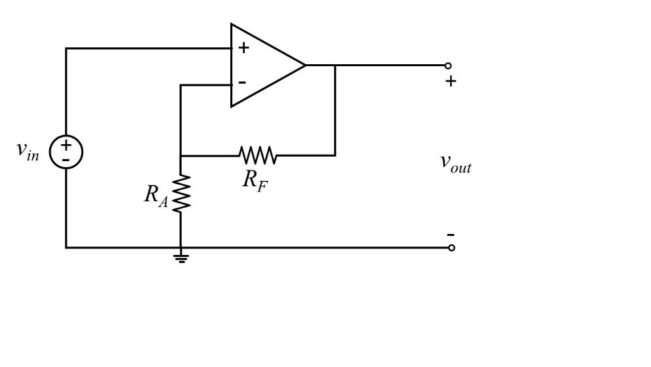

1. Using the ideal op-amp model, derive the expression for the voltage gain ${v_{out}}/{v_{in}}$ as a function of the two resistors *RA* and *RF*. [1 pt]
2. The op-amp circuit above is configured as a non-inverting amplifier. Using the ideal op-amp model, the voltage gain is ${v_{out}}/{v_{in}}=1+{R_{F}}/{R_{A}}$ as you found in part a). Choose resistance values for resistors *RA* and *RF* to design the op-amp circuit such that the voltage gain is +8 $V/V$  and the total power absorbed by the two resistors is 500 μW when *vout* = 2 V. [2 pt]
3. Using the practical op-amp circuit model simplified by setting the input resistance to infinity $\left(R_{i}→∞\right)$ and the output resistance to zero $\left(R_{o}=0 Ω\right)$, what is the output voltage value *vout* if $R_{A}→∞$, $R_{F}→0 Ω$, *vin* = 5 V, and the open-loop gain A is 15 $V/V$? [2 pt]
4. In the circuit described in part c), what is the output voltage value *vout* using the ideal op-amp model? [1 pt]

Extra Working Space